Campaign Presentation

Christmas Retail Holiday Campaign Analytics
Reporting Period: November2025 - December 2025
Prepared By :Yamin Wasi
Subject:Performance Review Of Holiday Campaign ROI

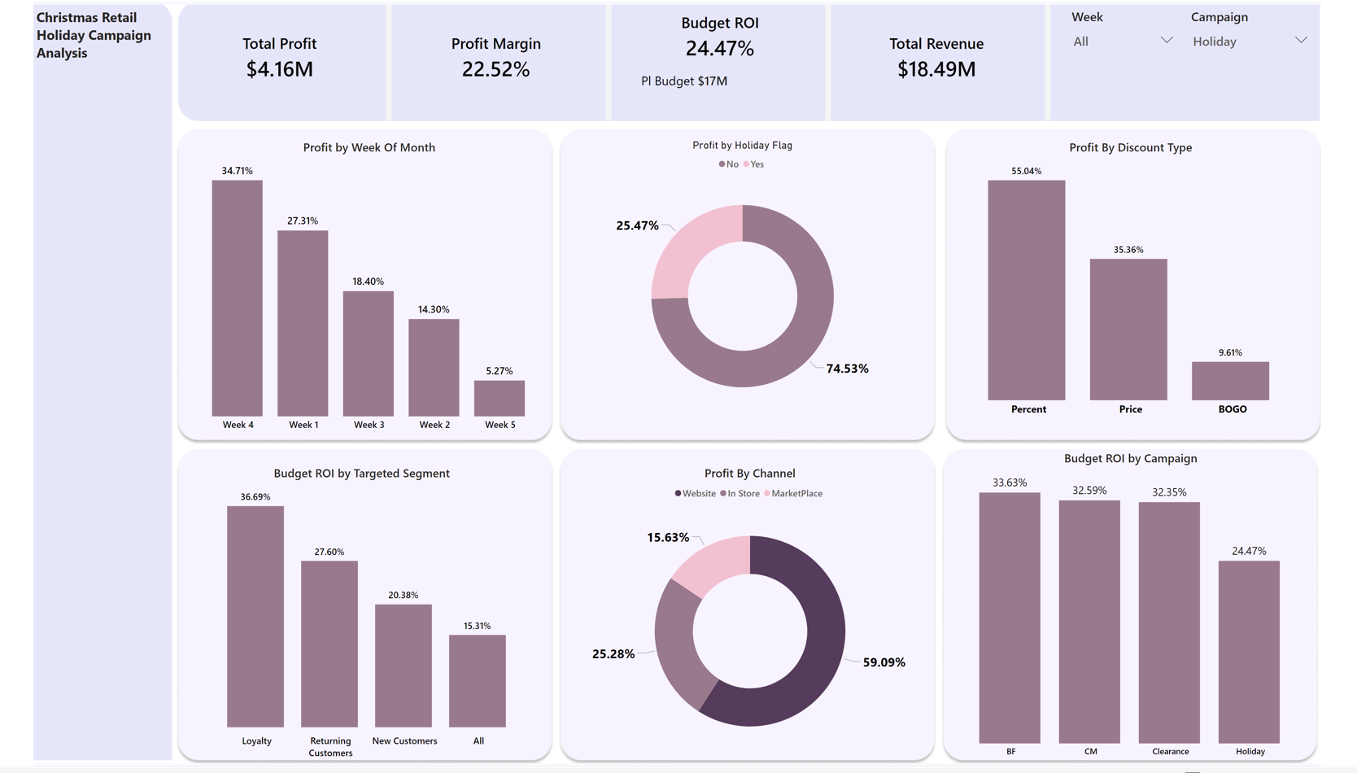

Executive Summary
These Dashboards provide a comprehensive analysis of the Retail Performance During the 2025 holiday season (November and December). Overall, the Holiday campaign successfully generated significant revenue with a healthy profit margin. Key highlights include a total revenue of 18.49M , Profit $4.16M overall Budget ROI of 24.47% against a $17M budget Which is a Great Indication.
Key Performance Indicator (KPIs) For Holiday Campaign
- $4.16M Profit on Holiday Campaign
- 25.52% Profit Margin on Holiday Campaign
- Budget ROI is 24.47% against $17M Budget
- Total Revenue $18 Million On Holiday Campaign
November & December Profit Margin Analysis
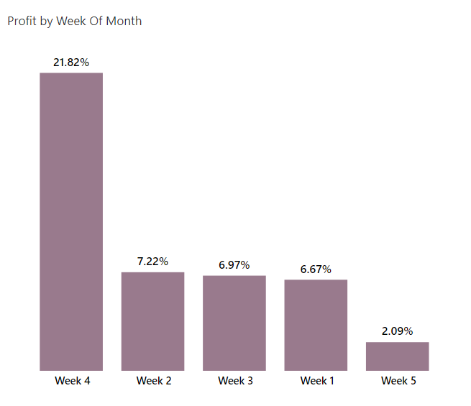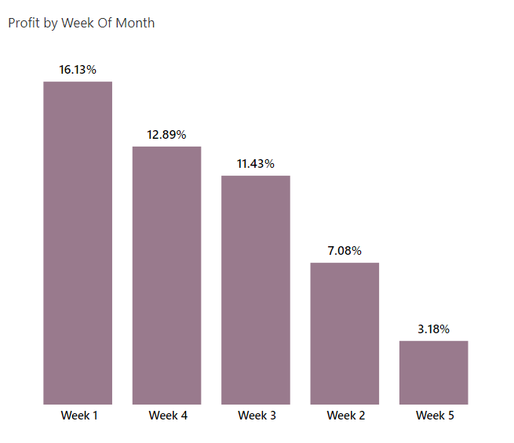
November Performance
- Peak: Profit peaked during Week 4 (Nov 22–28) at 21.8%, driven by the Holiday Campaign.
- Stability: Weeks 1, 2, and 3 maintained a consistent margin of 6%–7%.
- Month-End: Week 5 (Nov 29–30) saw a significant dip to approximately 2%.

December Performance
- Peak: Week 1 was the most profitable at 16%.
- Volatility: Profits dropped to 7.08% in Week 2, but showed a strong recovery through the end of the month.
- Recovery: Weeks 3 and 4 trended upward, finishing between 11% and 12.89% (approx. 13%).

Recommendations
Campaign Peak: The Holiday Campaign drove a month-high 21.8% margin in late November, proving the offer strategy was highly effective.
Early November Stability: Weeks 1–3 of November showed consistent "baseline" profitability at 6%–7%, indicating steady organic demand.
Post-Campaign Fatigue: The sharp drop to 2% on Nov 29–30 suggests a "cooling-off" period immediately following the peak campaign intensity.
December Momentum: December opened strong at 16%, likely capturing "Cyber Monday" spillover and early-month gifting intent.
The Week 2 "Dead Zone": Profitability plummeted to 7.08% in mid-December, marking the largest performance gap in the two-month period.
Urgency-Driven Recovery: Margins trended upward in late December (rising to ~13%) as shipping deadlines created customer urgency.
Margin Resilience: Despite the mid-month dip, December’s second half showed better price integrity than the early-November baseline.
Volatility Drivers: The fluctuation between 2% and 21% highlights that profitability is currently highly dependent on specific campaign dates.
Inventory Timing: The Dec Week 1 peak suggests inventory was well-positioned to meet the initial December surge.
Profit Optimization: The recovery in Dec Weeks 3–4 suggests that late-season shoppers were less price-sensitive, allowing for higher margins.

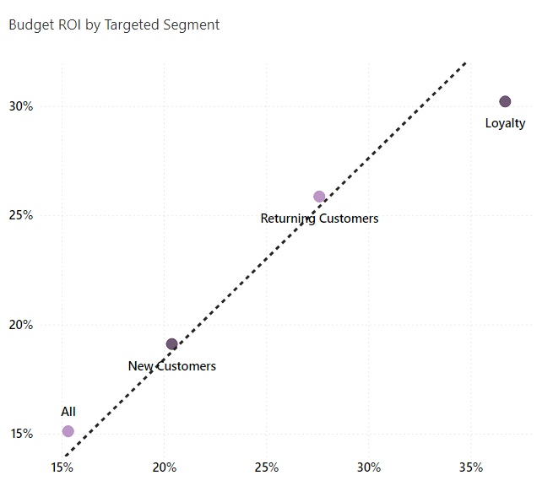
Budget ROI VS Profitability Analysis By Targeted Segment
(Holiday Campaign)
The Top Performer (Loyalty): This segment sits in the Top-Right of chart. It has both the highest ROI (36.7%) and the highest Profit Margin (30.2%). Insight: This is the most efficient and profitable group; continue prioritizing the budget here.
The Steady Middle (Returning Customers): Sits in the Center. With an ROI of 27.6% and Margin of 25.9%, it is a reliable performer that outperforms the "All" average.
The Acquisition Cost (New Customers): Sits Lower-Left of the other specific segments (20.4% ROI / 19.1% Margin). Insight: It is normal for New Customers to have lower margins due to the higher cost of acquisition, but they are still outperforming the "All" category.
The Baseline (All): This is The Anchor Point at the bottom (15.3% ROI / 15.1% Margin). Use this to show that your specific targeted campaigns (Loyalty/Returning) are significantly more successful than general broad targeting.

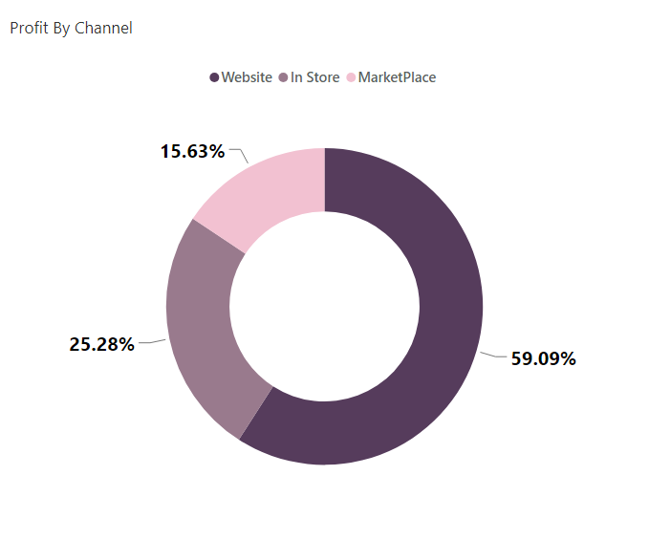
Profit By Channel (Holiday Campaign)
High-Volume Lead (Website): At nearly 60%, the website is "Big Player." Even a small 1% increase in website margin will have a much larger impact on the bottom line than any other channel.
The Physical Touchpoint (In-Store): contributing 1/4 of our profit, this channel supports our Loyalty and Returning Customer segments (who usually have the highest ROI).
Third-Party Presence (Marketplace):While our Marketplace ROI is 5.22%—lower than our 59% website contribution—it remains a profitable 'Discovery' channel. It allows us to capture 15% of our total profit from customers who shop exclusively on third-party platforms, without losing money on the ad spend.

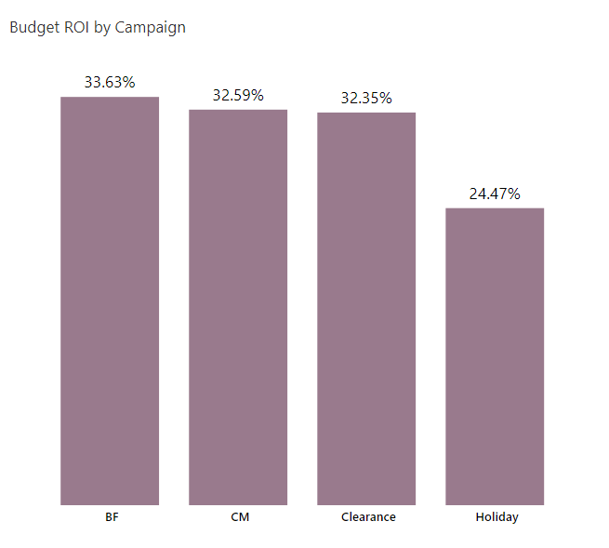

Metric definition: Budget ROI = Total Profit ÷ Planned Budget → measures profit efficiency, not sales volume.
Top performers: BF, CM, and Clearance all deliver ~32–34% ROI, indicating strong and consistent capital efficiency.
Best in class: BF leads at 33.63%, setting the benchmark for budget effectiveness.
Clearance insight: High ROI despite heavy discounting → inventory liquidation is profit-controlled, not margin-destructive.
Underperformance flag: Holiday campaigns trail at 24.47% ROI, materially below the portfolio average.
Root issue: Holiday spend is outpacing profit return, driven by higher discounts and fulfillment costs.
Strategic implication: ROI—not revenue—should guide budget allocation decisions.
Actionable takeaway: Reallocate incremental budget toward BF and CM; tightly govern Holiday spend unless profitability improves.

Delivery Effecensy
Delivery Efficiency Report
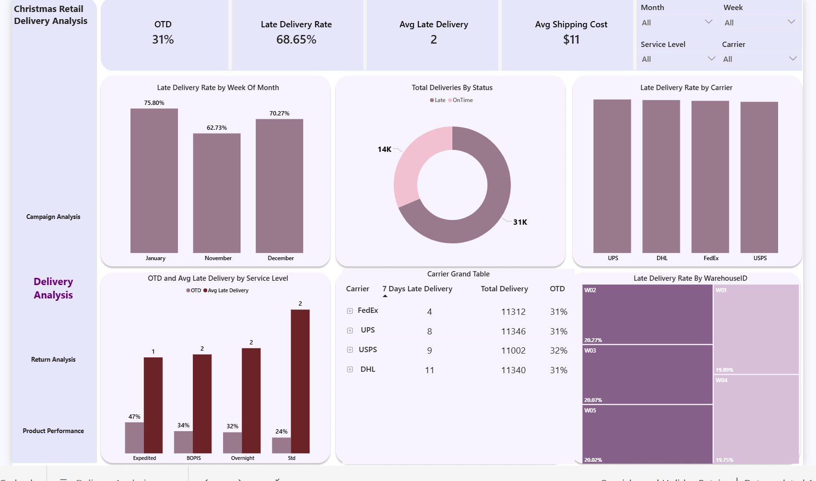
KPI Overview (Top tiles)
- OTD: 31% → materially below acceptable retail SLA.
- Late Delivery Rate: 68.65% → majority of customers impacted.
- Avg Late Days: 2 → delays are short but frequent, amplifying customer dissatisfaction.
- Avg Shipping Cost: $11 → premium spend is not translating into performance.
Late Delivery by Time (Week / Month)
- Late delivery peaks in January (75.8%), remains elevated in December (70.3%), and is still high in November (62.7%).
- This indicates post-holiday spillover, not just peak-week failure.
- Capacity constraints extended beyond the promotional window.
- Implication: Holiday demand is overwhelming downstream logistics well into January.

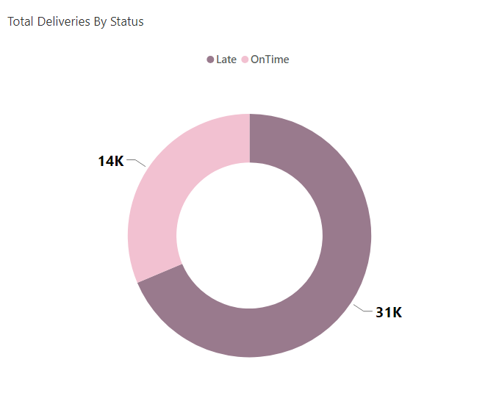

Delivery Status Mix (Donut Chart)

~31K deliveries late vs ~14K on time.

Late deliveries dominate total volume.

Implication: Late delivery is the norm, not the exception—this is a structural issue.
Carrier Performance

All carriers (UPS, DHL, FedEx, USPS) show similarly high late rates.

No clear “best carrier” emerges.

DHL shows the highest 7-day late deliveries despite similar volume.

Implication:This is not a single-carrier failure. Carrier diversification alone will not fix this.

Warehouse Performance

Late delivery concentration is highest in W02, W03, and W05 (~20% each).

Performance variance exists across warehouses.

Implication: Fulfillment execution is uneven—process and capacity gaps at specific nodes.

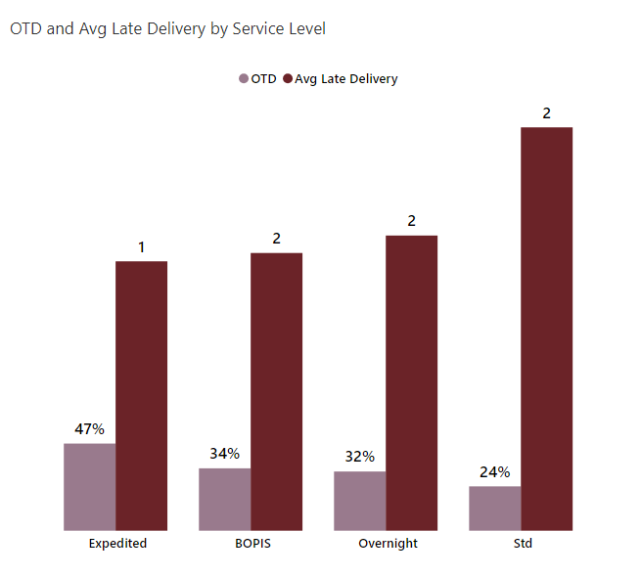

Service Level Analysis

Expedited: Highest OTD (47%) but still underperforming expectations.

BOPIS & Overnight: Mid-range OTD (~32–34%) with 2-day delays.

Standard: Lowest OTD (24%) and worst average lateness (2 days).

Key insight: Customers paying for speed are not consistently receiving it—brand trust risk.

Business Impact (Translate to money & CX)

High late rates directly drive:

Customer dissatisfaction and repeat-purchase risk

Increased support tickets and refunds

Inefficient shipping spend with low ROI

This directly undermines Holiday campaign profitability.

This dashboard shows that late delivery during the holiday season is not an anomaly—it’s a systemic execution gap. Until fulfillment capacity, warehouse performance, and service-level promises are aligned, increased shipping spend and aggressive promotions will continue to erode customer trust and profit

Strategic Recommendations — Omnichannel Holiday Sales

Reset delivery promises: Align holiday marketing and service-level commitments with actual fulfillment capacity to stop systematic over-promising.

Shift volume to controllable channels: Aggressively promote BOPIS and in-store fulfillment to reduce carrier dependency and improve on-time performance.

Fix fulfillment bottlenecks first: Prioritize capacity, staffing, and cut-off optimization in underperforming warehouses (W02, W03, W05).

Enforce carrier accountability: Move to SLA-linked contracts and route high-value orders based on proven on-time performance, not legacy allocation.

Protect premium margins: Throttle Expedited and Overnight services when OTD drops below threshold to avoid charging for unmet service levels.

Gate holiday campaigns: Require logistics sign-off and stress-tested capacity plans before launching peak promotions.

Product Performance
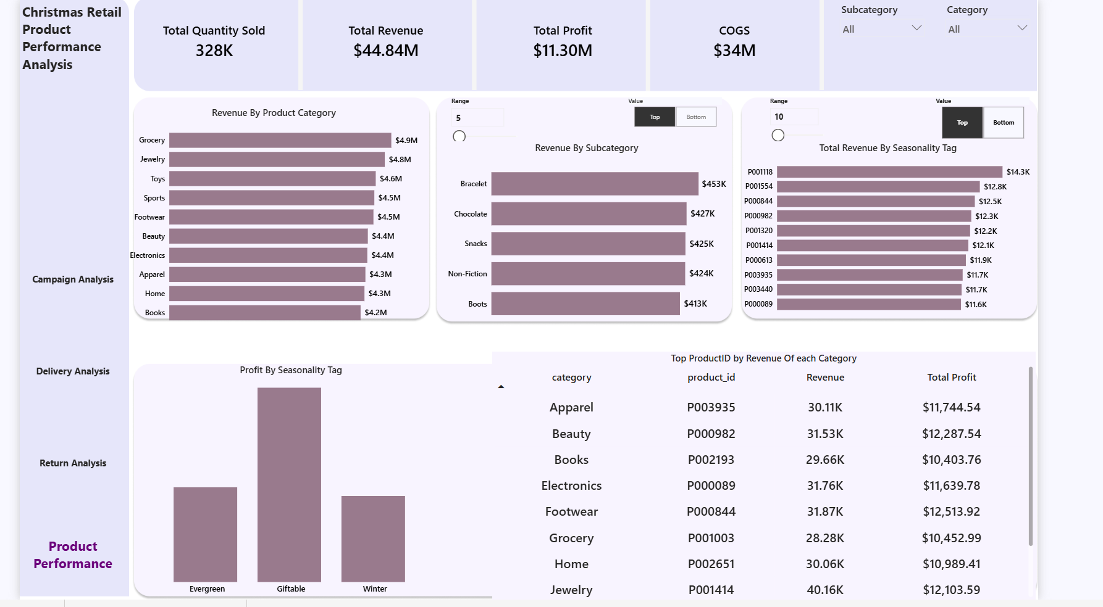
Executive KPI
Total Quantity Sold: 328K units: strong holiday demand across categories.
Total Revenue: $44.84M :high topline performance.
Total Profit: $11.30M : healthy margin contribution.
COGS: $34M : cost base is significant and must be actively managed.
Revenue by Product Category
- Revenue is well diversified across categories—no single-category dependency.
- Grocery, Jewelry, Toys, Sports, and Footwear lead revenue contribution.
- Lower-ranked categories still contribute materially, indicating a balanced assortment strategy.
Insight:
The holiday portfolio is resilient, but growth is driven by a small set of high-performing categories.

Revenue by Subcategory (Top Performers)
- Bracelets, Chocolate, Snacks, Non-Fiction, and Boots emerge as top subcategories.
- These products align strongly with holiday gifting and seasonal demand behavior.
- Performance is concentrated around impulse-friendly and giftable items.
Implication:
Subcategory performance validates customer intent—giftability and convenience win during holidays.
Revenue by Subcategory (Top Performers)
- Bracelets, Chocolate, Snacks, Non-Fiction, and Boots emerge as top subcategories.
- These products align strongly with holiday gifting and seasonal demand behavior.
- Performance is concentrated around impulse-friendly and giftable items.
Implication:
Subcategory performance validates customer intent—giftability and convenience win during holidays.
Revenue by Seasonality Tag
- Giftable products dominate revenue and profit, outperforming Evergreen and Winter-only items.
- Evergreen products provide stability but do not spike during peak season.
Winter-specific items perform well but lack the upside of Giftable SKUs.
Strategic takeaway:
Holiday success is driven more by gift relevance than pure seasonality.

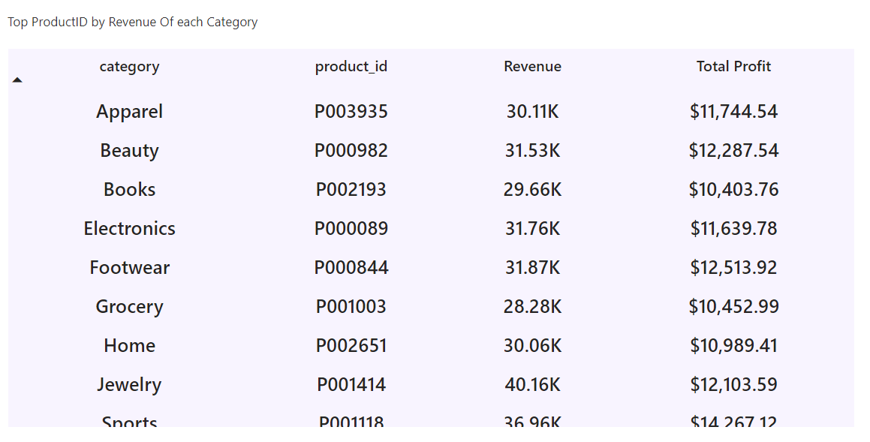
Top Product by Revenue Within Each Category (Table)
- This table isolates the single highest-revenue SKU per category.
- Each category has a clear hero product generating ~$10K–$12K+ profit.
- Categories like Footwear, Beauty, Jewelry, and Electronics show especially strong SKU-level economics.
Why this matters:
Holiday performance is driven by a small number of hero SKUs, not broad assortments.

Cross-Category Insight
- High-performing categories consistently align with:
  - Giftable attributes
  - Strong margins
  - Predictable demand
- Long-tail SKUs add complexity without proportional profit return.
Hard truth:
Assortment breadth increases operational cost without guaranteed payoff.

Top 10 Strategic Recommendations — Product Performance
- Double down on hero SKUs
Prioritize inventory, visibility, and replenishment for the top product in each category—these SKUs drive disproportionate revenue and profit.
- Design campaigns around Giftable products
Giftable items deliver the highest revenue and profit. Make them the centerpiece of holiday promotions, not a subset.
- Rationalize long-tail assortment
Reduce exposure to low-velocity SKUs during peak season to simplify operations and protect margin.
- Protect margin in high-volume categories
Actively monitor COGS for Grocery, Jewelry, Toys, and Footwear to prevent volume-driven margin erosion.
- Scale winning subcategories
Increase allocation and marketing support for Bracelets, Chocolate, Snacks, Non-Fiction, and Boots, which align with holiday buying behavior.
- Guarantee omnichannel availability of top SKUs
Ensure hero products are consistently available across online, BOPIS, and in-store to avoid lost sales.
- Shift promotions from discount-led to product-led
Promote specific high-performing SKUs instead of broad category discounts to improve ROI.
- Use seasonality tags as a planning lever
Treat Giftable as a strategic classification in demand planning, not just a label.
- Align inventory depth with profitability, not revenue
Allocate deeper stock to SKUs with proven profit contribution, not just high sales volume.
- Create a repeatable holiday playbook
Codify these insights into a standardized holiday assortment and promotion strategy for future cycle

